Lab report – Project Management

**LAB REPORT**

**Software Project Management**

**Student Name: Nguyen Thi Nga**

**ID: 21130791**

**Class: DHKHMT18A**

**Course: Quản lý dự án CNTT(420300405604)**

MỤC LỤC

MODULE 1: MANAGEMENT STUDIO 3

Exercise 1. Creating a link 3

Exercise 2. Setting duration 3

Exercise 3. Creating phases 3

Exercise 4. Noah - Linking 3

Exercise 5. Pyramid - Multi level grouping 3

Exercise 6. Creating a plan for Staff Training 3

Exercise 7. Recurring tasks 3

Exercise 8. Travelling – task calendar 3

MODULE 2: CALENDARS AND SCHEDULING 3

Exercise 1. Part Time - creating new calendar 3

Exercise 2. Changing Working Time 4

Exercise 3. Changing Working Time 5

Exercise 4. Changing Working Time 6

Exercise 5. Create the private Time for a project 8

Exercise 6. Your project 10

MODULE 3: WORKING WITH TASKS 10

Exercise 1. Changing Working Time (Start Date 1/3/2025) 10

Exercise 2. Changing Working Time (Start Date 1/03/2025) 11

Exercise 3. Scheduling – Task dependencies 11

# MODULE 1: MANAGEMENT STUDIO

## Exercise 1. Creating a link

Task:

* Default: start, duration, predescessor
* Summary: gom nhóm các task
* Task lặp đi lặp lại: Chu kỳ,
* Milstone: cột mốc

Creating the following tasks

|  |  |  |  |
| --- | --- | --- | --- |
| **ID** | **TASK NAME** | **PREDESCESSOR** | **DURATION** |
| **1** | Research destinations | - | 2 days |
| **2** | Book flights | 1 | 1 day |
| **3** | Prepare and pack | 2 | 5 days |
| **4** | Fly out | 3 | 1 day |
| **5** | Relax in the sun | 4 | 7 days |
| **6** | Fly home | 5 | 1 day |
| **7** | Peel | 6 | 7 days |

* Display the Project Information

* View Project Timeline, Gant Chart, Network Diagram and capture the result them.

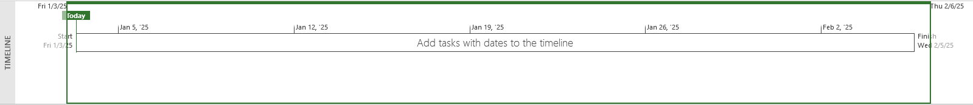

## Exercise 2. Setting duration

Creating the following tasks

|  |  |  |  |
| --- | --- | --- | --- |
| **ID** | **TASK NAME** | **PREDESCESSOR** | **DURATION** |
| **1** | Quarry stone | - | 2 days |
| **2** | Transport stone | 1 | 1 days |
| **3** | Prepare stone | 2 | 5 days |
| **4** | Fill foundations | 1,3 | 1 day |
| **5** | Level ground | 2,3 | 1 day |
| **6** | Measure site | 1 | 7 days |
| **7** | Mark out site | 5 | 5 days |
| **8** | Acquire stone | 2,4 | 3 days |
| **9** | Prepare site | 5,3 | 9 days |
| **10** | Build | 8,9 | 2 days |

* Display the Project Information

* View Project Timeline, Gant Chart, Network Diagram and capture the result of them.

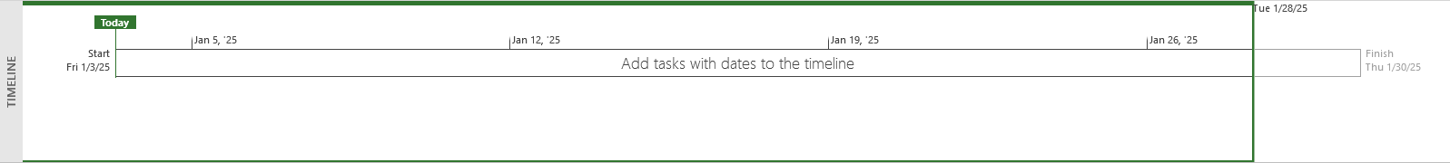

## Exercise 3. Creating phases

Creating the following tasks

|  |  |  |  |
| --- | --- | --- | --- |
| **ID** | **TASK NAME** | **PREDESCESSOR** | **DURATION** |
| **1** | Pre-heat oven | - | 5 mins |
| **2** | Prepare meat | 1 | 5 mins |
| **3** | Prepare veg | 2 | 5 mins |
| **4** | Heat pan | 3 | 5 mins |
| **5** | Fry veg | 4 | 5 mins |
| **6** | Brown meat | 5 | 5 mins |
| **7** | Add stock and bring to a simmer | 6 | 5 mins |
| **8** | Cook in oven | 7 | 45 mins |

* Group the eight tasks so that the first task becomes a summary task (Make a casserole 1 day?)
* Display the Project Information

* View Project Timeline, Gant Chart, Network Diagram and capture the result of them.

## Exercise 4. Noah - Linking

Create the following links

|  |  |  |  |
| --- | --- | --- | --- |
| **ID** | **TASK NAME** | **PREDESCESSOR** | **DURATION** |
| **1** | Build boat | - | 7 days |
| **2** | Load supplies | 1 | 3 days |
| **3** | Load family | 1 | 6 days |
| **4** | Load animals | 1 | 7 days |
| **5** | Collect animals A-M | 1,4 | 12 days |
| **6** | Collect animals N-Z | 2,4 | 10 days |
| **7** | Float around | 5,6 | 7 days |

* Display the Project Information

* View Project Timeline, Gant Chart, Network Diagram and capture the result of them.

## Exercise 5. Pyramid - Multi level grouping

Create the following links

|  |  |  |  |
| --- | --- | --- | --- |
| **ID** | **TASK NAME** | **PREDESCESSOR** | **DURATION** |
| **1** | *Build a pyramid* | *-* | *1 day?* |
| **2** | *Acquire stone* | 1 | *1 day?* |
| **3** | Quarry stone | 2 | 3 wks |
| **4** | Transport stone | 3 | 5 days |
| **5** | Prepare stone | 4 | 3 wks |
| **6** | *Prepare site* | 5 | *1 day?* |
| **7** | Dig foundations | 6 | 3 wks |
| **8** | Fill foundations | 7 | 2wks |
| **9** | Level ground | 8 | 1wk |
| **10** | Measure site | 9 | 7 days |
| **11** | Mark out site | 10 | 7 days |
| **12** | Build | 11 | 6 mons |

* Group the tasks as indicated above with 3 levels:
* Level 1 at task 1 includes task 2,6,12
* Level 2 at task 2 includes task 3,4,5, task 6 includes task 7,8,9,10,11
* Display the Project Information

* View Project Timeline, Gant Chart, Network Diagram and capture the result of them.

## Exercise 6. Creating a plan for Staff Training

|  |  |  |  |
| --- | --- | --- | --- |
| **ID** | **TASK NAME** | **PREDESCESSOR** | **DURATION** |
| **1** | Start with a skills gap analysis. | - | 7 days |
| **2** | Identify employees for career | 1 | 3 days |
| **3** | Align with employee and company goals. | 2 | 6 days |
| **4** | Help them grow with you | 3 | 7 days |
| **5** | *Use employee development plan* | *4* | *1 days?* |
| **6** | Consider an individual employee | 5 | 2 wks |
| **7** | A succession planning template | 6 | 1wks |
| **8** | *Fit the learning opportunity to the training* | *7* | *1 days?* |
| **9** | Microlearning | 8 | 2 wks |
| **10** | On-the-job training | 9 | 5wks |
| **11** | Augmented reality | 10 | 1wks |
| **12** | Track results to inform your decisions | 11 | 7 days |

* Group the tasks as indicated above with 3 levels:
* Level 1 at task 1,2,3,4,5,8,12.
* Level 2 at task 5 includes task 6,7 and task 8 includes task 9,10,11
* Display the Project Information

* View Project Timeline, Gant Chart, Network Diagram and capture the result of them.



## Exercise 7. Recurring tasks

Create plan for a software project

|  |  |  |  |
| --- | --- | --- | --- |
| **ID** | **TASK NAME** | **PREDESCESOR** | **DURATION** |
| **1** | Planning | - | 1 wk |
| **2** | Requirement documents | 1 | 2 wks |
| **3** | Sign off | 2 | 1 day |
| **4** | Development | 3 | 10 wks |
| **5** | Testing | 4 | 4 wks |
| **6** | Implementation | 5 | 2 wks |
| **7** | Review | 6 | 1 wk |

* Add in a weekly meeting to run throughout the project with the following settings
* Name: Breakfast Meeting
* Duration: 1 hour
* Recurrence: Weekly
* Day: Monday
* Range: 08/01/2025 at 08:00 to end of the project.
* Calendar: Standard
* Display the Project Information

* View Project Timeline, Gantt Chart, Network Diagram and capture the result of them.

## Exercise 8. Travelling – task calendar

You intend to travel from HCM to Kuala Lumpur, Bangkok and then, come back to HCM. Creating a plan for your trip.

# MODULE 2: CALENDARS AND SCHEDULING

## Exercise 1. Part Time - creating new calendar

Open project file **Ex2 (Module 1)**, Use the Project Information dialog box to:

* A part-time worker will be used on this project. Go to the Change Working Time dialog box

and create a new copy of the Standard calendar, calling it "Part Time".

* Update the working time of your new calendar so that:
* Mondays to Fridays are nonworking time
* The remaining 2 weekdays have working time of 10:00 to 16:00 ( no breaks)
* The Part time has also booked a holiday from 1 to 5 Jan. Create an Exception to their calendar

with a Holiday name and these days as nonworking

* Display the Project Information.

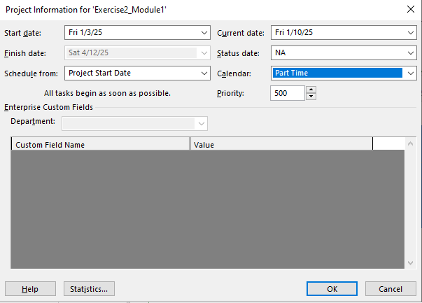

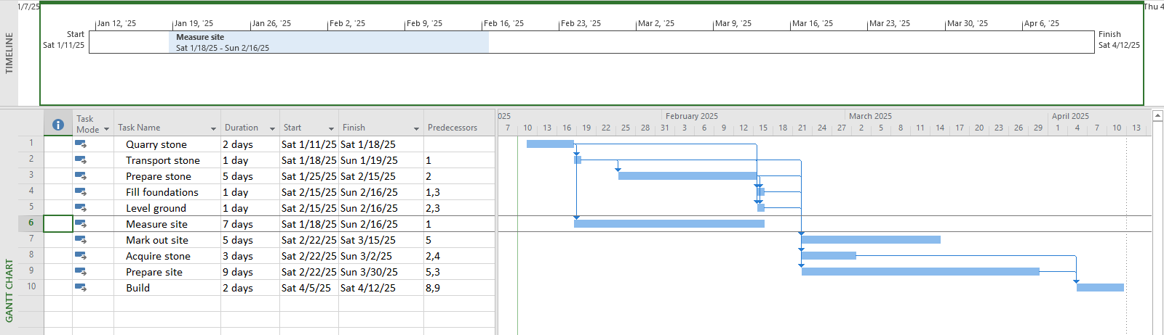

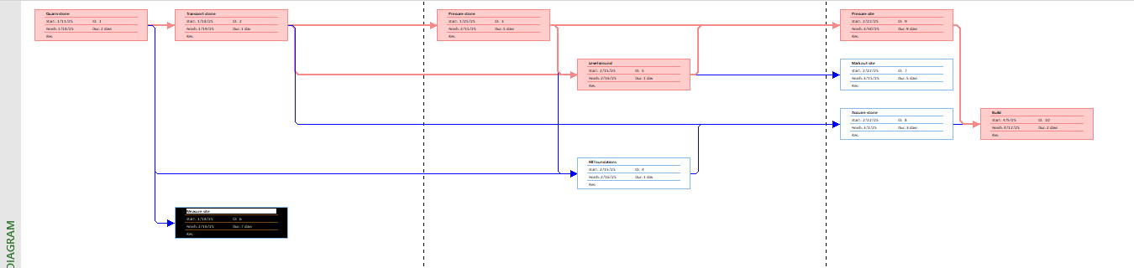

## Exercise 2. Changing Working Time

Open project file **Ex4 (Module 1)** Use the Project Information dialog box to:

* Go to the Change Working Time dialog box and create an Exception called "Tet Holidays" during from 25 Dec 2024 to 3 Jan 2025 into nonworking time.
* Change Work Weeks time of Standard calendar's default working week. This project's standard working time are:
* 08:30 to 17:30 Monday to Thursday (no lunch break)
* 08:30 to 16:00 on Fridays (no lunch break)
* Add a new Work Week to the Standard calendar named "Xmas Slowdown". Use this to

model a 12:30 finish on every weekday from 23 Dec 2024 to 5 Jan 2025.

* Capture the Work weeks time

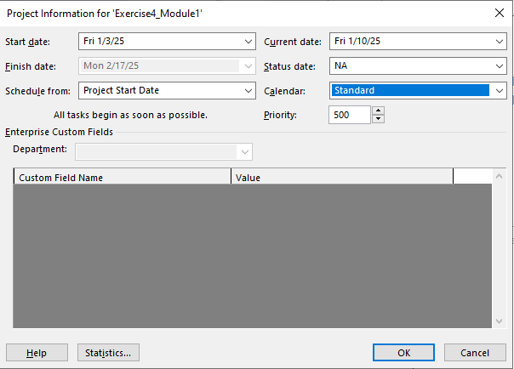

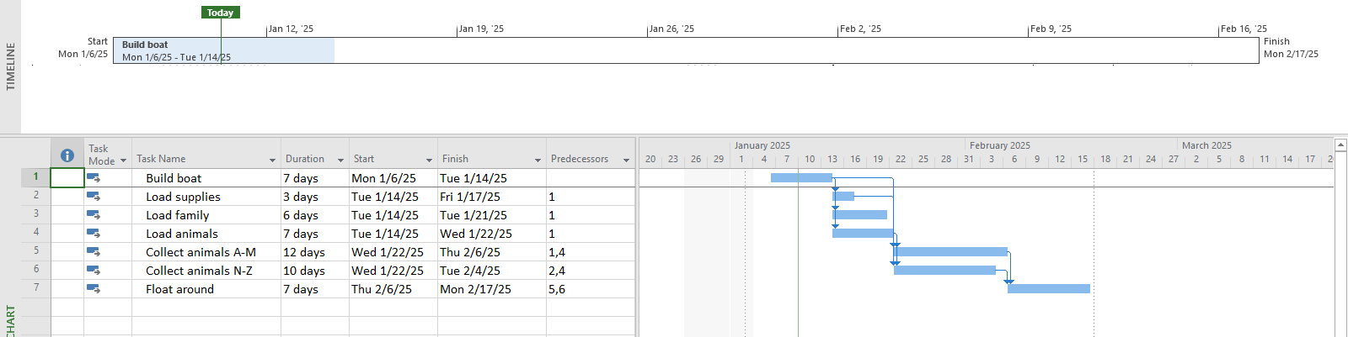

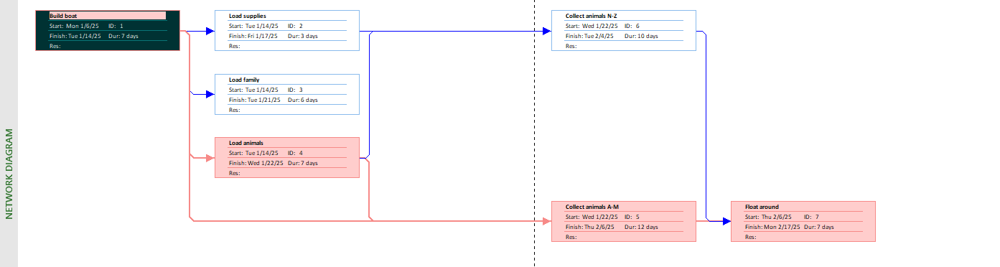

## Exercise 3. Changing Working Time

Open project file **Ex5 (Module 1),** Use the Project Information dialog box to:

* The office will shut down for 2 weeks in the summer. Use the Change Working Time dialog box to create an Exception called "Summer Shutdown" and make the first 14 workdays of August nonworking time
* Create an Exception called “Independence Days” is 2 Sep nonworking time.
* Create an Exception called “International Labor days” is 30 Apr and 1 May nonworking time
* Display the Project Information

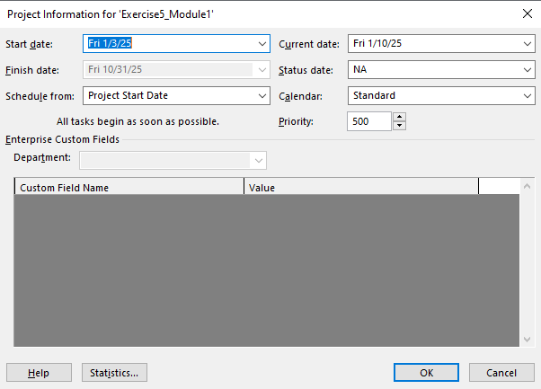

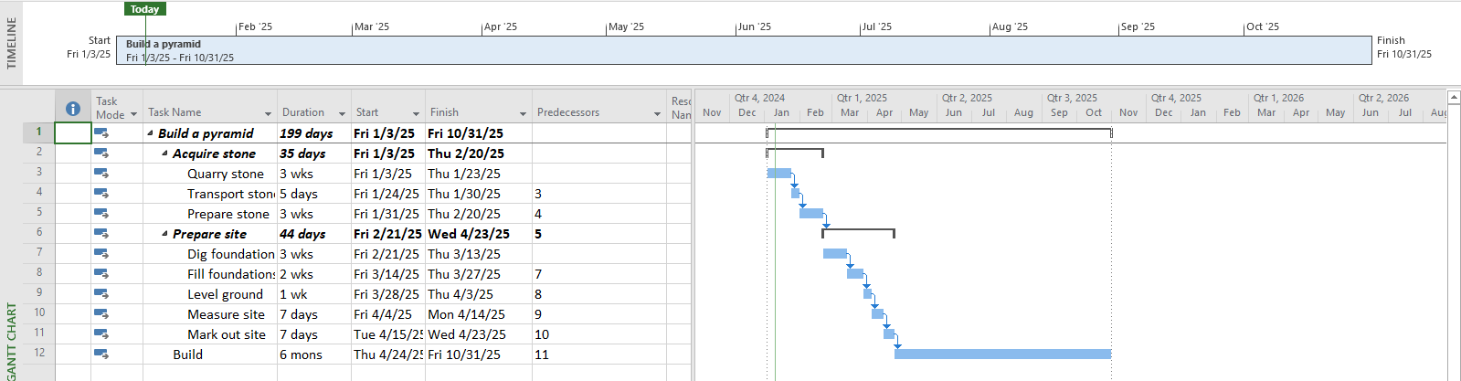

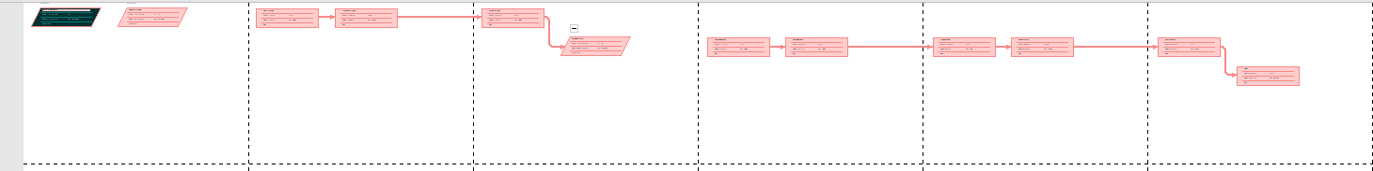

## Exercise 4. Changing Working Time

* Open project file **Ex6 (Module 1),** Use the Project Information dialog box to schedule it to start on Nov 1st of next year.
* Modify the Standard calendar and change the [Default] work week to use the hours shown below:



* Add an exception in the Standard calendar called Recovery with in 7 lates workdays of March is non-working days
* Display the Project Information.

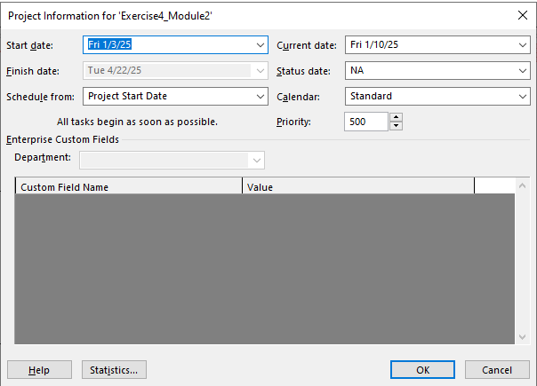

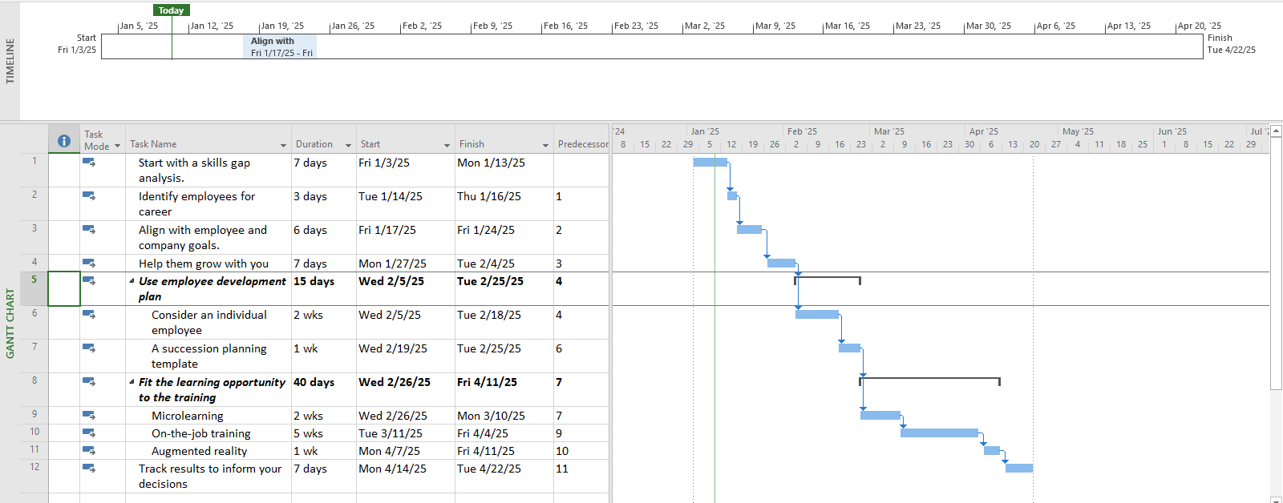



## Exercise 5. Create the private Time for a project

Open project file **Ex7 (Module 1),** Use the **Project Information** dialog box to:

* Create the new Time Work for your project. [NameTimeProject]

{Name: Your Name - Ex: MinhTimeProject}

* Change Work Weeks time of Standard calendar's default working week. This project's standard working time are:
* 08:00 to 12:00 on Mon, Wed, Fri
* 13:00 to 16:00 on Tue, Thu, Sat
* Create an Exception called “International Labor days” is 30 Apr and 1 May nonworking time
* Capture the Work weeks time

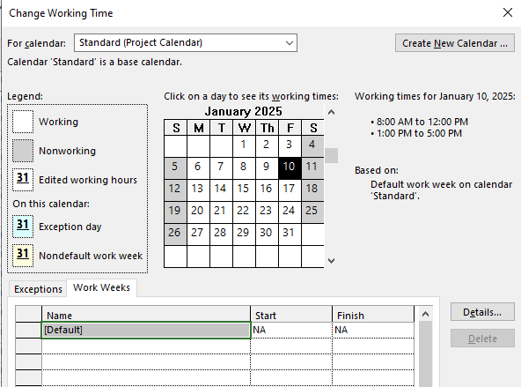

* Display the Project Information

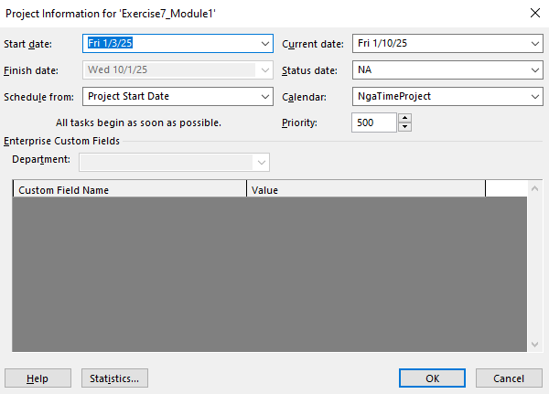

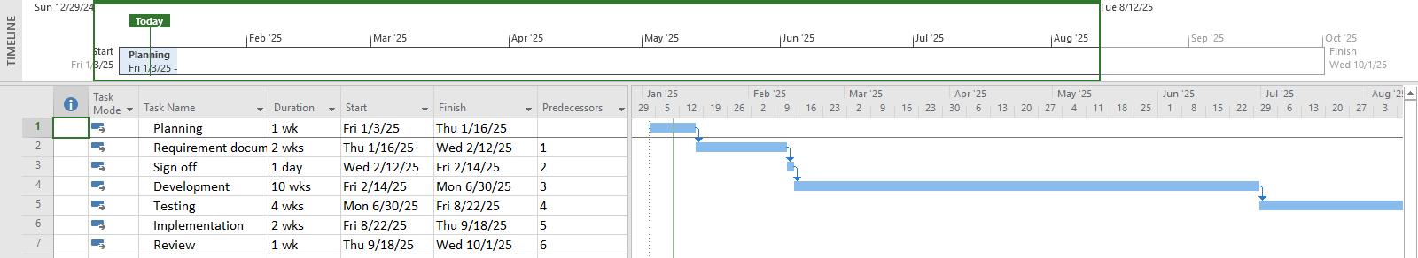

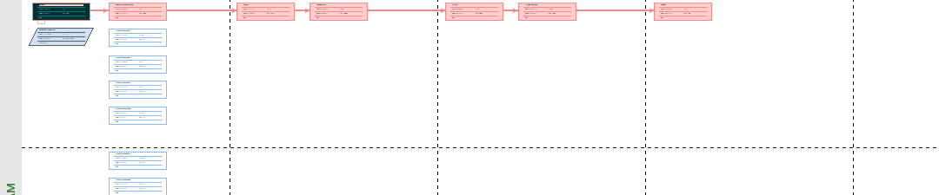

## Exercise 6. Your project

* Create your plan from Monday to Sunday. It will list all of your activities, your time you spend and resources joining in each task.
* Create a new calendar called **Student** based on the **Standard** calendar.
* Change the **[Default]** work week so that the hours match to your calendar everyday
* Using Note function in MP 2010 to take note for important tasks in your plan.

# MODULE 3: WORKING WITH TASKS

## Exercise 1. Changing Working Time (Start Date 1/3/2025)

|  |  |  |  |
| --- | --- | --- | --- |
| ID | TASK NAME | PREDECESSOR | DURATION |
| 1 | clean machine | NaN | 5 days |
| 2 | load raw materials | 1 | 3 days |
| 3 | prime machine | 2 | 3 days |
| 4 | Test run | 3 | 1 day |
| 5 | clean machine | 4 | 5 days |
| 6 | load raw materials | 5 | 3 days |
| 7 | prime machine | 6 | 3 days |
| 8 | Test run | 7 | 1 day |

Create the summary tasks for series tasks below:

* Summary task name is **Boy’s Toy** for tasks 1,2,3,4
* Summary task name is **Girl’s Toy** for tasks 5,6,7,8
* Add the **Ready for production task** (0 day) that is the end task of the task list
* Summary Task name is **Workshop** for **Boy’s Toy**, **Girl’s Toy, and Ready for production tasks**
* Display the Project Information.
* View Project Timeline, Gantt Chart, view CP, Total Slack and capture the result of them

## Exercise 2. Changing Working Time (Start Date 1/03/2025)

* Using the diagram below, create a list of tasks to model this process.

|  |  |  |  |
| --- | --- | --- | --- |
| **ID** | **TASK NAME** | **PREDECESSOR** | **DURATION** |
| 1 | Visit estate agents | NaN | 1 days |
| 2 | View properties | 1 | 2 days |
| 3 | Decide what to buy | 2 | 5 days |
| 4 | Make offer | 3 | 0 day |
| 5 | Wait for decision | 4 | Don't know |
| 6 | Offer accepted | 5 | 0 days |

* Create the summary task is Buy a shop that contains all tasks in the project.
* Establish the duration of **Wait for a decision task** is 7 days.
* Change the duration of **View properties task** to **7 days**.
* Display the Project Information.
* View Project Timeline, Gantt Chart, view CP, Total Slack and capture the result of them.

## Exercise 3. Scheduling – Task dependencies

**Create the list of tasks to model this processing (Start date: 1/3/2025)**

|  |  |  |
| --- | --- | --- |
| **ID** | **TASK NAME** | **Duration** |
| 1 | Creating architectural plans | 3 wks |
| 2 | Submit plans for approval | 1 mon |
| 3 | Order materials | 8 days |
| 4 | Erect fencing | 3 days |
| 5 | Erect site building | 4 days |
| 6 | Clear and level site | 3 wks |
| 7 | Prepare drainage infrastructure | 1 wk |
| 8 | Prepare cabling infrastructure | 1 wk |
| 9 | Pour foundations | 4 days |
| 10 | Erect steelwork | 3 mons |
| 11 | Erect wall | 2 mons |
| 12 | Install roofing superstructure | 2 wks |
| 13 | Install roofing retracting mechanism | 1 wk |
| 14 | Erect seating tiers | 3 wks |
| 15 | Fit all windows and doors | 2 wks |
| 16 | Install electrical cabling | 1 wk |
| 17 | Install electrical fittings and fixtures | 2 wks |
| 18 | Install all plumbing | 2 wks |
| 19 | Install plumbing fixtures and fittings | 1 wk |
| 20 | Lay astro turf | 1 wk |
| 21 | Erect handrails and fencing | 2 wks |
| 22 | Paint rooms, fixtures, fittings, etc. | 1 mon |
| 23 | Install PA system | 2 days |
| 24 | Install video imaging equipment | 3 days |
| 25 | Fit out control room | 1 wk |
| 26 | Test roof mechanism | 1 wk |
| 27 | Test PA system | 2 days |
| 28 | Test video imaging equipment | 2 days |
| 29 | Test control room equipment | 1 wk |
| 30 | Obtain official occupancy | 1 day |
| 31 | Obtain safety certification | 2 days |
| 32 | Official opening | 1 day |

**Create the summary tasks for series tasks below:**

* Summary task name is **Planning (20 days)** for tasks 1,2,3.
* Summary task name is **Site Works (15 days)** form task 4 to task 8.
* Summary task name is **Building Construction (60 days)** form task 9 to task 14.
* Summary task name is **Fit Out (20 days)** form task 15 to task 25.
* Summary task name is **Commissioning (5 days)** form task 26 to the end task.

**Create the milestones for this project below:**

|  |  |  |
| --- | --- | --- |
| **No** | **Milestone** | **At End Of phrases** |
| 1 | Planning Completed | Planning |
| 2 | Site Works Completed | Site works |
| 3 | Building Construction Completed | Building Construction |
| 4 | Fit Out Completed | Fit out |
| 5 | Commissioning Completed | Commissioning |

**Creating Dependencies in Task Entry**

|  |  |  |  |
| --- | --- | --- | --- |
| **ID** | **TASK NAME** | **Duration** | **Dependencies** |
| **1** | Planning |  |  |
| **2** | Creating architectural plans | 3 wks | 1 |
| **3** | Submit plans for approval | 1 mon | 2 |
| **4** | Order materials | 8 days | 3 |
| **5** | Planning Completed | 0 | 2, 3, 2004 |
| **6** | Site works |  | 5 |
| **7** | Erect fencing | 3 days | 6 |
| **8** | Erect site building | 4 days | 7 |
| **9** | Clear and level site | 3 wks | 8 |
| **10** | Prepare drainage infrastructure | 1 wk | 9 |
| **11** | Prepare cabling infrastructure | 1 wk | 9 |
| **12** | Site works Completed | 0 | 7, 8, 9, 10, 11 |
| **13** | Building Construction |  | 12 |
| **14** | Pour foundations | 4 days | 13 |
| **15** | Erect steelwork | 3 mons | 14 |
| **16** | Erect wall | 2 mons | 15 |
| **17** | Install roofing superstructure | 2 wks | 16 |
| **18** | Install roofing retracting mechanism | 1 wk | 17 |
| **19** | Erect seating tiers | 3 wks | 18 |
| **20** | Building Construction Completed | 0 | 14, 15, 16, 17, 18, 19 |
| **21** | Fit Out |  | 20 |
| **22** | Fit all windows and doors | 2 wks | 21 |
| **23** | Install electrical cabling | 1 wk | 21 |
| **24** | Install electrical fittings and fixtures | 2 wks | 23 |
| **25** | Install all plumbing | 2 wks | 21 |
| **26** | Install plumbing fixtures and fittings | 1 wk | 25 |
| **27** | Lay astro turf | 1 wk | 21 |
| **28** | Erect handrails and fencing | 2 wks | 21 |
| **29** | Paint rooms, fixtures, fittings, etc. | 1 mon | 28 |
| **30** | Install PA system | 2 days | 23 |
| **31** | Install video imaging equipment | 3 days | 23 |
| **32** | Fit out control room | 1 wk | 29, 30, 31 |
| **33** | Fit Out Completed | 0 | 22, 23, 24, 25, 26, 27, 28, 29, 30, 31, 32 |
| **34** | Commissioning |  | 33 |
| **35** | Test roof mechanism | 1 wk | 34 |
| **36** | Test PA system | 2 days | 33 |
| **37** | Test video imaging equipment | 2 days | 33 |
| **38** | Test control room equipment | 1 wk | 35, 36, 37 |
| **39** | Obtain official occupancy | 1 day | 38 |
| **40** | Obtain safety certification | 2 days | 39 |
| **41** | Official opening | 1 day | 40 |
| **42** | Commissioning Completed | 0 | 35, 36, 37, 38, 39, 40, 41 |

Display the Project Information.

* View the project in Gantt Chart and define CP and Project Slack
* Choose **Gantt Chart Format** tab → check on ***Critical Tasks*** in ***Bar Styles.***



* *Check on* ***Slack*** in ***Bar Styles*** slack lines in non-critical tasks
* On the table data Add column **Late Start**, **Late Finish**, **Total Slack**